CHEM 6572
Pymol Assignment 5, Turns

Copy and paste the commands below (altogether)
#-----------------------------------------------------------------------------
## Header: General Commands ##

# delete all objects and reset pymol
reinitialize
# set the background color to white
bg_color white
# make the background transparent for ray trace
set ray_opaque_background, 0
# set the ray trace mode
# normal color
set ray_trace_mode, 0
# normal color + black outline
#set ray_trace_mode, 1
# black outline only
#set ray_trace_mode, 2
# turn off shadows during ray trace
set ray_shadows, 0
# set the mouse mode for laptop.
config_mouse one_button
# get rid of double bonds and skinny bonds to H
set stick_h_scale, 1
set valence, 0
# high quality surfaces
set surface_quality, 3

## End of Header: General Commands ##
#----------------------------------------
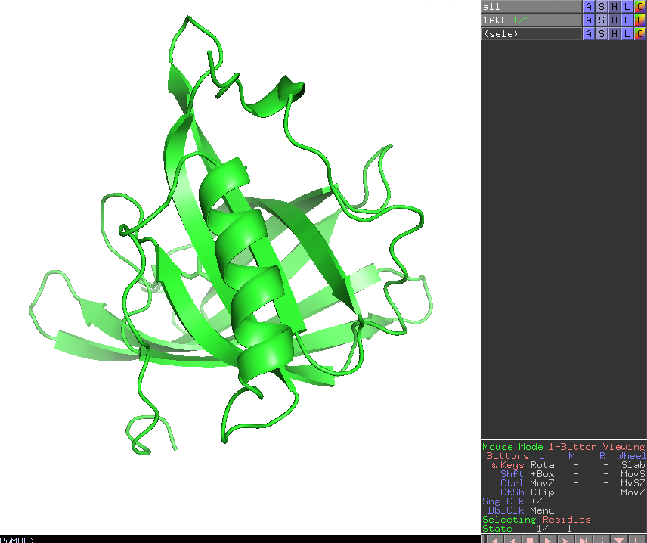
You might have to press escape after the carriage return

Load the coordinate file 1AQB, which is Retinol-Binding Protein (RBP) from Pig Plasma

Type (copy and paste all together)
﻿fetch 1AQB
﻿remove resname HOH or resname CD

The purpose of the remove command is to make things simple. For this exercise we are only interested in the polypeptide, not in water molecules or ions.

Identify the regions that look like they could be tight turns. Focus on the regions that are not helices or sheets. Rotate the structure around and click on the potential loop regions to find residues beginning and end that make a turn. Then select these residues and make them into a new object. For example, section 63 to 67 looks interesting.

type (copy and paste, all together)
create turn1, resi 63-67
color blue, turn1 and name N
color wheat, turn1 and name C*
color red, turn1 and name O
hide everything, turn1
show sticks, turn1
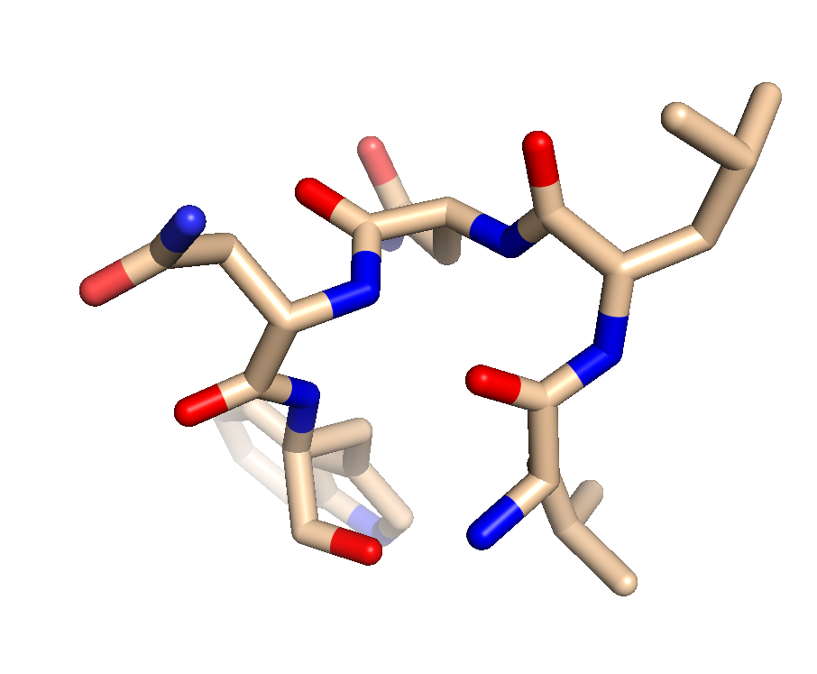
Here we have colored the atoms with the command line and have turned of the cartoon display and turned on sticks. Turn off all the objects is except turn1 (use the buttons on the RH side). You should see this. Find the strand directionality. Make sure you can see N-Cα-C’-N-Cα-C’-N-Cα-C’-. Click on the atoms to identify them

Now, add the hydrogen atoms. Use Action -> hydrogens -> add
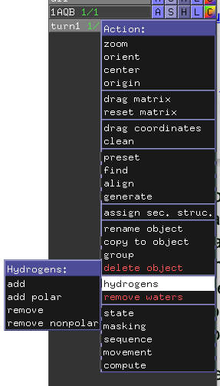

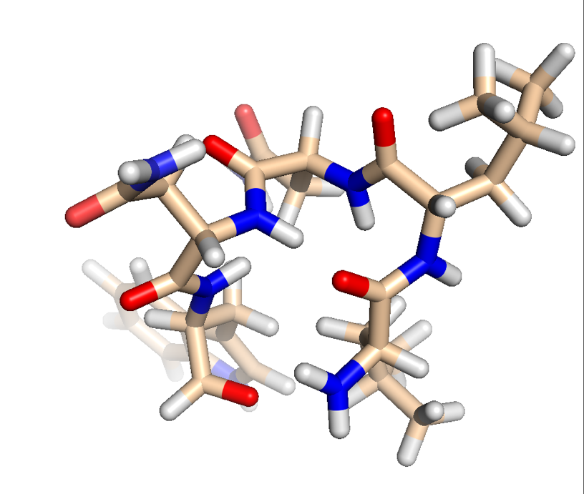
The display should now look like this:

Now fin H-bonds using Action->Find->Polar->Within Selection.

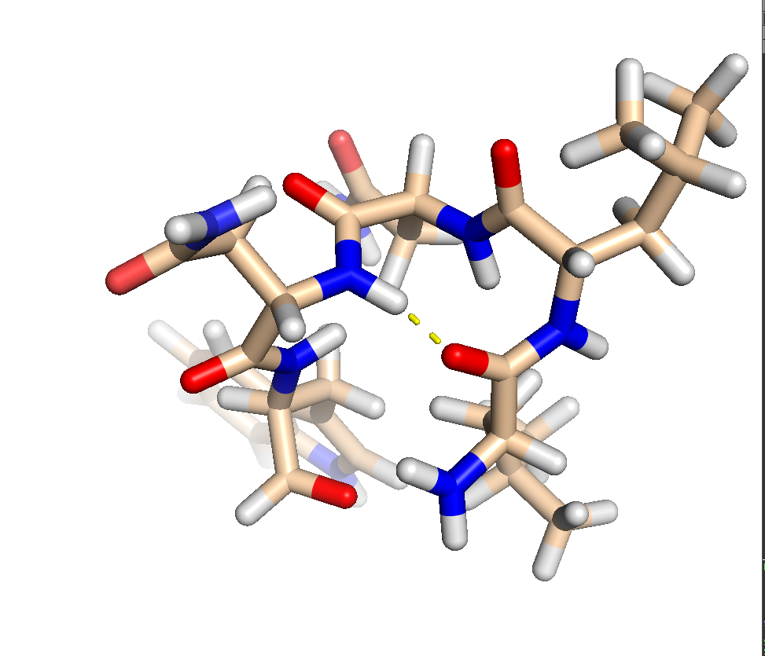
The display will show the H-bond that is closing the turn.:

Next, find another tight turn and repeat this process. If you are having trouble finding residue numbers, click on the cartoon, the amino acid number that you clicked on will be shown above the command line. Here I gave clicked on residues 47 and 52, that seem to form the start and end of a turn.
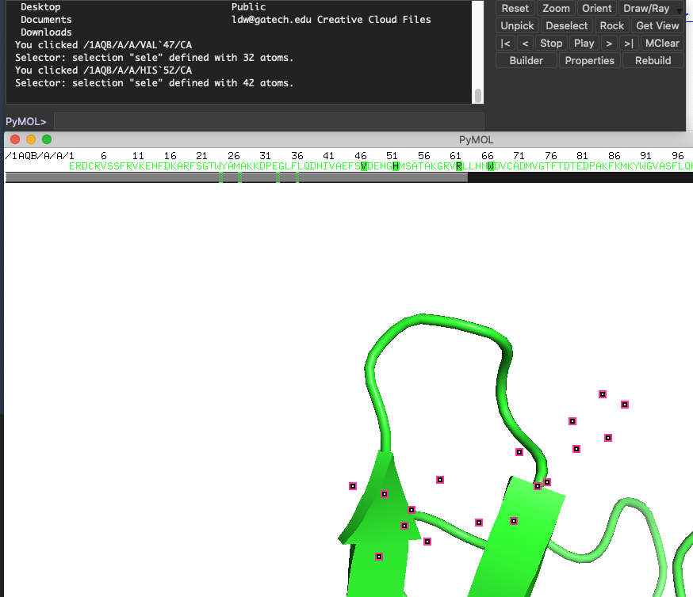

Take the red text above (page 2) copy it and edit it. Change resi 63-67 to resi 47-52 (or whatever you want). Change turn1 to turn2 (everywhere). Using this method, make images of several turns or loops, with hydrogens on and showing hydrogen bonds. Put the images in a word doc and describe each in 2-3 sentences.

Phi /Psi.
Obtain the phi and psi angles for your objects.

Type (copy and paste all together). This set of commands will give you all the phi (green) and psi (cyan) of turn1.

dihedral phi_turn1, (resi 63 and name C and turn1), (resi 64 and name N and turn1), (resi 64 and name CA and turn1), (resi 64 and name C and turn1)
dihedral phi_turn1, (resi 64 and name C and turn1), (resi 65 and name N and turn1), (resi 65 and name CA and turn1), (resi 65 and name C and turn1)
dihedral phi_turn1, (resi 65 and name C and turn1), (resi 66 and name N and turn1), (resi 66 and name CA and turn1), (resi 66 and name C and turn1)
dihedral phi_turn1, (resi 66 and name C and turn1), (resi 67 and name N and turn1), (resi 67 and name CA and turn1), (resi 67 and name C and turn1)
color green, phi_turn1
dihedral psi_turn1, (resi 64 and name N and turn1), (resi 64 and name CA and turn1), (resi 64 and name C and turn1), (resi 65 and name N and turn1)
dihedral psi_turn1, (resi 65 and name N and turn1), (resi 65 and name CA and turn1), (resi 65 and name C and turn1), (resi 66 and name N and turn1)
dihedral psi_turn1, (resi 66 and name N and turn1), (resi 66 and name CA and turn1), (resi 66 and name C and turn1), (resi 67 and name N and turn1)
dihedral psi_turn1, (resi 67 and name N and turn1), (resi 67 and name CA and turn1), (resi 67 and name C and turn1), (resi 68 and name N and turn1)
color cyan, psi_turn1

You can modify this series of commands, by copy and paste into a word doc, then editing it to change resi and name, to determine phi and psi for any object. Only edit the red text below. Note that this coordinate file leaves the prime off of C’.

dihedral psi_turn1, (resi 64 and name N and turn1), (resi 64 and name CA and turn1), (resi 64 and name C and turn1), (resi 65 and name N and turn1)

For phi, the atoms are always in order C,N,CA,C
For phi, the residue numbers always to order n-1,n,n,n

For psi, the atoms are always in order N,CA,C,N
For psi, the residue numbers always to order n,n,n,n+1

Calculate all the phi and psi for at least five turns of 1AQB. Get at least 30 phi/psi pairs. Make a table of the phi psi values for each turn, and graph them all together in an x,y scatter plot. Assign the turns as either a Type I β -Turn, a Type II β - Turn, or Not a Beta Turn. Use Jane Richardson’s description below of Type I and Type II β-turns. The C’ that forms the H-bond to close the loop is part of the first amino acid of a β-turn.

Note: the phi psi values do not need to be an exact match with values provide in the Richardson attachement (next).


